During this unprecedented time, individuals with disabilities are disproportionately affected. The negative effects range from economic to psychological. In general, people feel better when they have control and are able to help in some way. You have the opportunity to help the individuals in The Arc of the South Shore’s group homes to give back in a special way. Please consider purchasing some materials needed to make Hope Rocks. Hope Rocks are a creative art project that help to spread joy. Individuals will paint rocks with images and words of encouragement and place them around their neighborhood (practicing safe social distancing, of course) to help uplift the community.

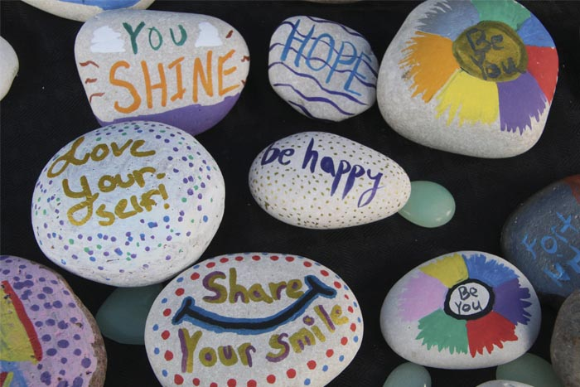

We need:

Set of 24 Acrylic Paint Pens 0.7 mm for Rock Painting, Ceramic, Porcelain, Glass, Stones, Pebbles, Fabric, Wood & DIY Mug Design. Permanent Water Based Medium Tip Marker Pen (24pcs-0.7mm) – 10 @ $17.99/ea.

Rock Canvas Painting Rocks - 4.5lbs of Smooth Rocks for Painting, Assorted Size and Shapes 3-5 Inch, About 8-10 Rocks - Stone Perfect for Easy Painting, Kindness and Crafts – 10 @ $18.99/ea

During this unprecedented time, individuals with disabilities are disproportionately affected. The negative effects range from economic to psychological. In general, people feel better when they are able to maintain communication with those they care about and help in some way. You have the opportunity to help the individuals in The Arc of the South Shore’s group homes to keep communication and give back in a special way. Please consider purchasing some materials needed to make Thank You Cards. These supplies will allow individuals to make unique and personalized Thank You Cards for essential employees, first responders and those on the front lines that they care about during these challenging times. Cards allow a great and important message be sent from a safe distance.

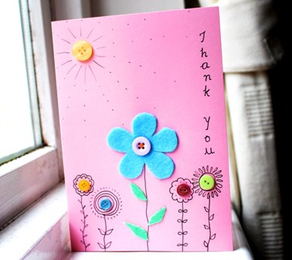 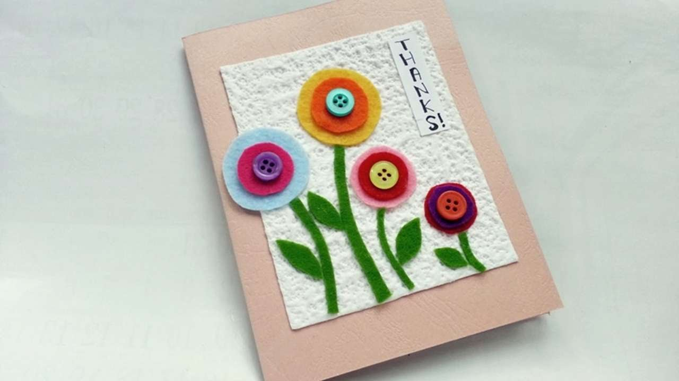

**We need:**

American Greetings Single Panel Blank Cards with Envelopes, Rainbow (200-Count) – 5503990 – 10 @ $14.98/ea

Thank You w/Stars Self Inking Rubber Stamp (Blue Ink) - Large – 10 @ $9.99/ea

AmazonBasics Fine Point Tip Permanent Markers, Black, 12-Pack – 10 @ $5.49/ea

Aleene's Original 3 Pack, 8 oz Tacky Glue, 3 Count – 10 @ $7.31/ea

Coopay 120 Pieces Felt Flowers Fabric Flower Embellishments Assorted Colors for DIY Crafts – 10 @ $8.99/ea

BIHRTC Pack of 300 Mixed Color 3 Different Size Round Felt Circle Felt Pads for DIY and Sewing Handcraft (0.8"-100pcs, 1.2"-100pcs, 1.8"-100pcs) – 10 @ $6.00/ea

Hygloss Products Bucket O Assorted Buttons for Arts and Crafts, 4-Ounce, 4 Oz – 10 @ $5.31/ea

During this unprecedented time, individuals with disabilities are disproportionately affected. The negative effects range from economic to psychological. In general, people feel better when they are able to express themselves creatively. You have the opportunity to help the individuals in The Arc of the South Shore’s group homes to get creative. Please consider purchasing some materials needed to make A Spring Dandelion Painting. These supplies will allow individuals to make unique and personalized Spring Dandelion Painting to keep for themselves, enter into The Arc of the South Shore’s art show or silent auction, or give as a gift. With Mother’s Day and Father’s Day quickly approaching, this painting is a great gift idea.

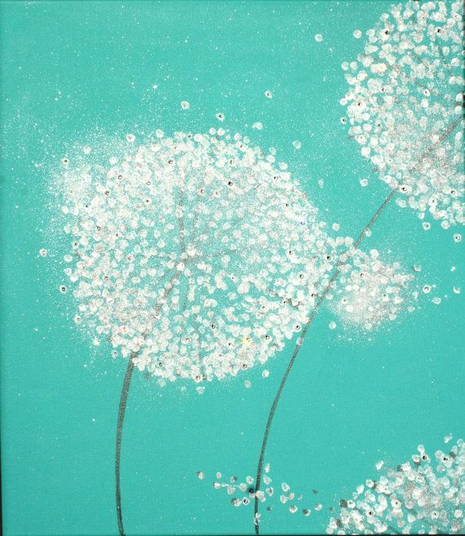

We Need:

### Arteza 8"x10" Stretched White Blank Canvas, Bulk (Pack of 12), Primed 100% Cotton, for Painting, Acrylic Pouring, Oil Paint & Wet Art Media, Canvases for Professional Artist, Hobby Painters & Beginner – 10 @ $24.98

### Dental Check 6 Pack Charcoal Toothbrush | Natural Teeth Whitening Solution | Ultra-Soft Bristles for Dental Care | Angled Bristles for Hard-To-Reach Areas | Clean Away 99% Of Plaque & Brighten a Smile – 10 @ $5.49

### FolkArt 50559E Plaid Nylon Brush Set, 50559 Brown (3-Piece) – 50 @ $3.97

### Apple Barrel Acrylic Paint in Assorted Colors (16 Ounce), 21136 Kelly Green – 10 @ $4.28

### Apple Barrel Acrylic Paint in Assorted Colors (16 Ounce), 21119 White – 10 @ $13.98

### Apple Barrel Acrylic Paint in Assorted Colors (16 Ounce), 21148 Black – 10 @ $4.47