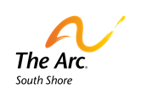

**(Chair) Exercise Spelling Challenge**

Choose your name, the day of the week, or a word of the day and create an at-home workout each day

*The Arc of the South Shore does not have rights to these photographs. This was made for the purpose of providing visual supports to individuals.

A – 10 sit and reaches (both sides)

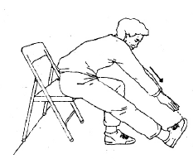

B – 10 leg lifts (both sides)

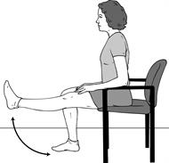

C – 10 bicep curls (both sides)

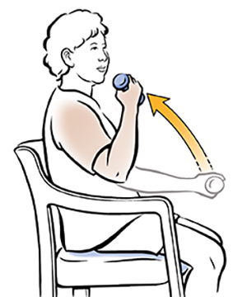

D – 10 leg circles (both sides)

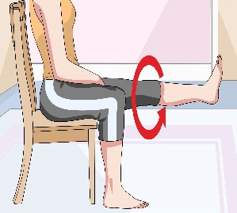

E – 15 sit-downs

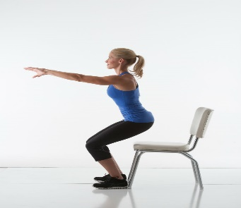

F – 10 arm circles (both sides)

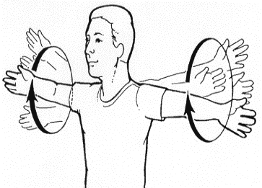

G – 10 arm raises (both sides)

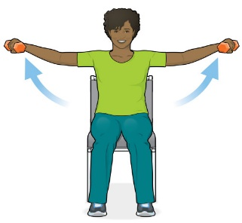

H – 10 shoulder rolls (both sides)

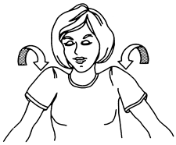

I – 10 heal and toe raises (both sides)

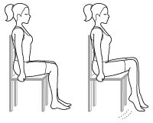

J – 15 starfish

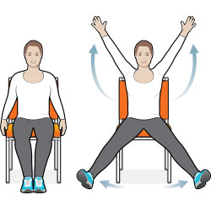

K – 10 shoulder shrugs (both sides)

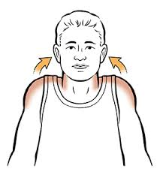

L – 15 self-hugs

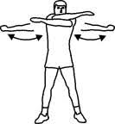

M – 10 side stretches (both sides)

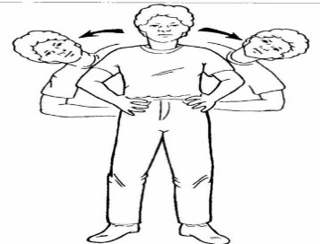

N – 15 seconds bicycle

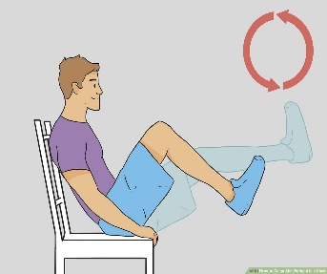

O – 15 crunches

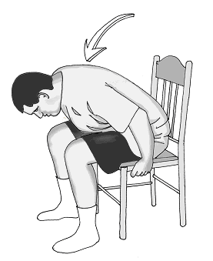

P – 10 peck flies

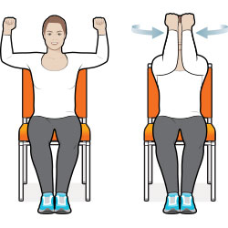

Q – 15 second march in place

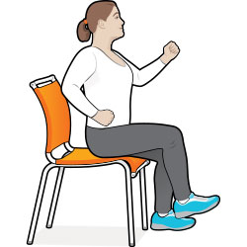

R – 15 torso twists

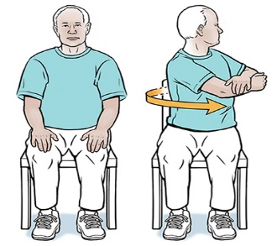

S – 10 scissor kicks

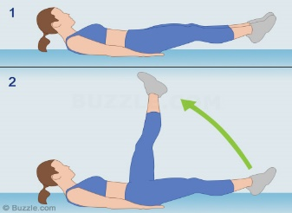

T – 10 fist to flat hand (both sides)

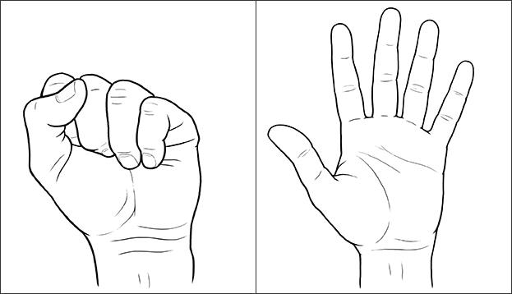

U – 10 deep breaths

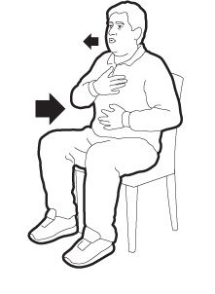

V – 10 hand turns (both sides)

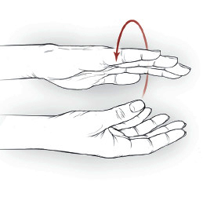

W – 10 seated cat cows

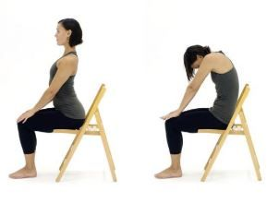

X – 10 ankle circles (both sides)

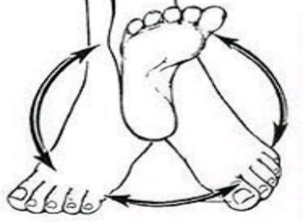

Y – 10 second hip stretch (both sides)

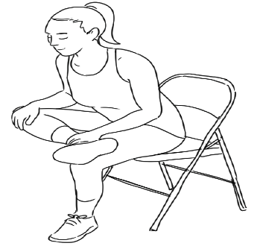

Z – 10 wrist flips (both sides)

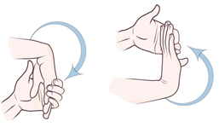

**Alternate Exercises (if one is too difficult or not recommended)**

10 goal posts

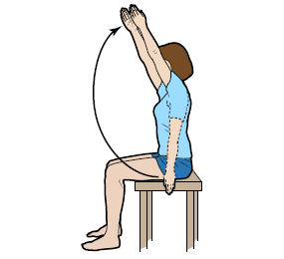

10 punches (both sides)

