Online/Phone Resources for Recovery Support, Parenting, and COVID-19
Compiled by Institute for Health and Recovery

RECOVERY SUPPORTS
The Mass. Substance Use Helpline continues to offer referrals and general information about SUD, as well as links to resources available during the COVID-19 crisis https://helplinema.org/covid-19-resources-for-ma/

Alcoholics Anonymous
AA Phone Meetings http://aaphonemeetings.org/
AA Western MA Intergroup Virtual Meetings https://westernmassaa.org/aa-meeting-schedules
AA en Espanol https://aa-intergroup.org/languages/index_es.html
AA Boston https://aaboston.org/
AA Search by State: https://www.aa.org/pages/en_US/find-aa-resources
AA Intergroup http://aa-intergroup.org/
AA Online Grouphttps://www.onlinegroupaa.org/
The Token Shop maintains a list of online meetings that is updated regularly. You can search by day and time and they include the topics of specific meetings: https://www.thetokenshop.com/Online_AA_Meetings

Pause a while Free conference calls for AA meetings at 2pm every day
- Dial in number: 425-436-6360
- Access Code: 422932

A Virtual Awakening Closed online AA meetings for women, trans, and non-binary people
Sun, Mon, Wed, Fri at 8:30pm EST, Thurs 1:00pm EST
https://zoom.us/j/4822208285

Narcotics Anonymous
New England Region of Narcotic Anonymous Virtual Meeting list: https://nerna.org/nerna-virtual-meetings/
Phone meetings: www.nabyphone.com
Global Online meetings: https://virtual-na.org/
Free NA Speaker Streaming 24-7 www.naspeaker.com
Never Alone Club Online Meetings https://www.neveraloneclub.org/
NA in Multiple Languages: https://virtual-na.org/meetings/

Cocaine Anonymous offers online support and services
https://www.ca-online.org

Gamblers Anonymous
Massachusetts Hotline Number: 855-2CALLGA (855-222-5542), GA virtual Meeting on In the Rooms and http://newenglandga.com/ hosting phone meeting every night of the week from 9:00-11:00 PM Eastern time. Phone Number 712-770-4160 – Access Code 611704#.

Marijuana Anonymous
http://marijuana-anonymous.org/find-a-meeting/
Nicotine Anonymous
www.nicotine-anonymous.org - has many online and telephone meetings, with a list available on the website

Recovery Speakers: Listen to recovery speakers from many different 12 step groups
www.recoveryspeakers.com
Embark Recovery: Daily 12pm & 6 pm in English and 12:30 and 5:30 in Spanish)
https://www.embarkreco.com/events
Herren Project: Variety of meetings, including Women’s Meeting Tuesdays at 7:30PM
https://herrenproject.org/recovery-meeting/
In the Rooms: online meeting at 9am, 12pm, 3pm, 6pm, 9pm. These are “all recovery” meetings and any pathway or programs are welcome.
https://www.intherooms.com/home/category/community-and-meetings/
https://www.intherooms.com/livemeetings/
LifeRing Secular Recovery is an organization of people who share practical experiences and sobriety support, and embraces what works for individual.
https://www.lifering.org/online-meetings
Lion Rock Recovery: Variety of support groups every day of the week
https://www.lionrockrecovery.com/online-aa-meetings-and-support-groups
Recovery Dharma has meetings using Buddhist practice
https://recoverydharma.online/
Reddit Recovery offers a virtual hang out and support during recovery
https://www.reddit.com/r/REDDITORSINRECOVERY/
Refuge Recovery provides online and virtual support
http://bit.ly/refugerecovery1
SMART Recovery
https://www.smartrecovery.org/community/ has a wide variety of online resources
http://www.smartne.org/meetings.html: has a listing of meetings but also a link for online meetings
SoberCity offers an online support and recovery community
https://www.soberocity.com/
Sobergrid offers an online platform to help anyone get sober and stay sober
https://www.sobergrid.com/
Soberistas provides a women-only international online recovery community
https://soberistas.com/
Sober Mommies: online support group for moms in recovery
https://sobermommies.com/groups/online-support/
Sober Recovery provides an online forum for those in recovery and their friends and family
https://www.soberrecovery.com/forum
WEconnect and Unity Recovery - 4 times daily 7 days a week (9am,12pm,3pm,9pm EST)
Join directly from computer or smart phone - unityrecovery.zoom.us/my/allrecovery
- unityrecovery.zoom.us/my/allrecovery
Women for Sobriety –https://womenforsobriety.org/ (website) https://wfsonline.org/ (online meetings)
Helps women gain hope and encouragement with other women in similar circumstances. Offering tools to a healthier lifestyle.

SUPPORTS FOR FAMILIES WITH A LOVED ONE WITH SUD
Al-anon Electronic meetings for anyone affected by alcoholism in a family member or friend
Al-anon.org/electronic-meetings
Allies in Recovery Online support for families dealing with a loved one’s addiction, using the evidence-based CRAFT method (Community Reinforcement and Family Training ); free for Massachusetts residents.
https://alliesinrecovery.net/
Learn to Cope
https://www.learn2cope.org/
Smart Recovery Family
Smartrecovery.org/family

FREE YOGA AND FITNESS
Phoenix Gym offers a range of FREE virtual exercise classes (meditation, yoga, CrossFit, etc. for people in recovery. Every 2 hours from 7 am - 9pm https://thephoenix.org/virtual/
Down Dog Yoga: https://www.downdogapp.com/
Trauma-informed Yoga/The Trauma Institute in Boston: https://www.traumasensitiveyoga.com/online-tctsy.html
Peloton App (offering free trial for 90 days, no bike)
Alo Yoga: https://www.youtube.com/channel/UCJEi1foUiGObzzQM3QA2H5A

RECOVERY APPS (download to your smartphone via app store/google play/website)
- Sober Grid - App Store
- Celebrate Recovery - App Store
- Smart Recovery - www.smartrecovery.org
  - Connections smartphone app to support recovery
https://www.addictionpolicy.org/connections-app

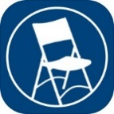
MEETING GUIDE is a free mobile app focused on helping people find A.A. meetings and resources near them. Also included are DAILY REFLECTIONS – a selection of reflections by and for A.A. members.
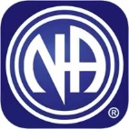 NA MEETING SEARCH is a free mobile app developed to help find an NA meeting. It can use your current location to display the meetings nearest you. Daily JUST FOR TODAY meditations are also bundled in this app. http://www.nabyphone.com/

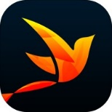 RECOVERY PATH is a free mobile app is designed to allow people to navigate their own path to sustained recovery, share progress with others, and receive support.
Online Resources to Support Your Recovery
Scan the QR code below to go directly to the type of support you are looking for.
- Online AA Meetings  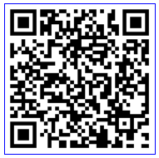 | - Recovery Dharma Online Meetings  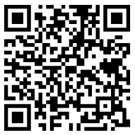 | - In the Rooms Online Support  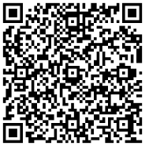
- Al-Anon Electronic Meeting List  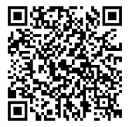 | - Online Group AA Meetings  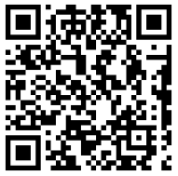 | - Substance Abuse and Mental Health Services Website  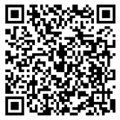
- Virtual Narcotics Anonymous Meetings  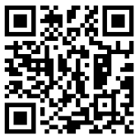 | - Smart Recovery Online  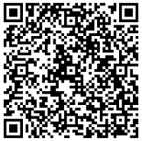 | - Never Alone Club – 24 Hour Chat and Support  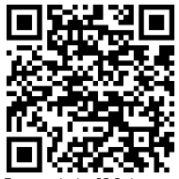
- Narcotics Anonymous by Phone  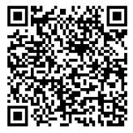 | - Marijuana Anonymous Online Meetings  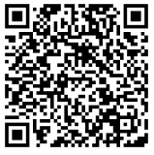 | - Connections App – tools to support early recovery  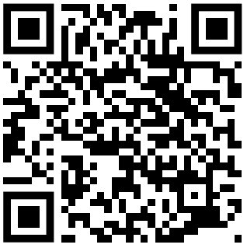
- The Herren Project – Recovery Meetings  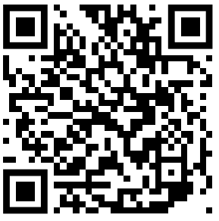 | - AA speaker tape and 12 steps – iPhone App  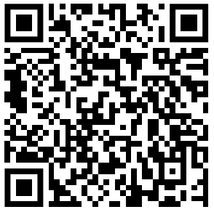 | - Smokefree – Tools and Support to Quit Smoking  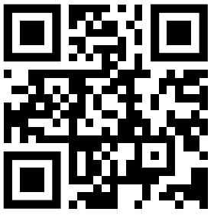

Facebook Recovery Groups (logon to Facebook, search group, ask to join)
- CLEAN AND SOBER - Addiction Recovery Support Group
- Daily Reflections AA
- Massachusetts Organization of Addiction Recovery
- Methadone & Buprenorphine Discussion and support
- MIPSA-Methadone Information & Patient Support Network
- Mommy Group
- Recovery Soldiers
- Send it! (Recovery Network)
- Sober Mommies
- Virtual Recovery – Meetings At Home
- Voices To End Addiction & Inspire Recovery
- Women in AA

RECOVERY CENTER FACEBOOK PAGES
A New Way Recovery Center, Quincy
https://www.facebook.com/A-New-Way-Recovery-Center-447672198690167/
Alyssa's Place Peer Recovery Center, Gardner
https://www.facebook.com/Alyssas-Place-Peer-Recovery-and-Resource-Center-1036671136361774/
Devine Recovery Center, South Boston
https://www.facebook.com/DevineRecoveryCenter
Everyday Miracles Peer Recovery Center, Worcester
https://www.facebook.com/EDMPeersPeer 2 Peer Recovery Support Center, Fall River
https://www.facebook.com/P2PRSC/
Hope for Holyoke Recovery Center, Holyoke
https://www.facebook.com/HFHRC/
Living in Recovery, Pittsfield
https://www.facebook.com/Living-In-Recovery-102917867894826/
New Beginning Recovery Center, Lawrence
https://www.facebook.com/New-Beginnings-1400295300266527/
No One Walks Alone (NOWA) PRSC, Whitinsville
https://www.facebook.com/NOWARSC/SC
Northampton Recovery Center, Northampton
https://www.northamptonrecoverycenter.org/calendar
PIER Recovery Center of Cape Cod, Hyannis
https://www.facebook.com/Pier-Recovery-Center-of-Cape-Cod-1214021491947603/
Plymouth Recovery Center, Plymouth
https://www.facebook.com/PlymouthRecoveryCenter/
Stairway to Recovery, Brockton
https://www.facebook.com/Stairway2Recovery

RECOVERY CENTER FACEBOOK PAGES (continued)
STEPRox Recovery Support Center, Roxbury
https://www.facebook.com/StepRoxRecoverySupportCenter

The RECOVER Project, Greenfield
https://www.facebook.com/TheRECOVERProject
The Recovery Connection, Marlborough
https://www.facebook.com/therecoveryconnection.org
Turning Point Recovery Center, Walpole
https://www.facebook.com/Turning-Point-Recovery-Center-100326408019268/

OTHER RESOURCES

7cups offers free emotional support. No matter what you are going through you will be heard and cared for. 24/7 chat.
https://www.7cups.com/online-therapy/

Local Crisis Hotlines
- Northampton CSO 413-586-5555
- Greenfield CSO 413-774-5411
- Holyoke BHN 413-532-8016
- Springfield BHN 413-733-6661
National Domestic Violence Hotline offers help to people experiencing violence in their home during COVID-19 restrictions. There is a hotline, texting service, and webchat service. https://www.thehotline.org/2020/03/13/staying-safe-during-covid-19/
National Suicide Prevention Lifeline
- 800-273-8255

Project Bread’s FoodSource Hotline provides up-to-date information– in multiple languages – about what is happening in school districts and what resources are available, such as SNAP application assistance, and referrals to open community resources.
The FoodSource Hotline can be reached at 1-800-645-8333 or
by chat at Gettingsnap.org

Samaritans: Helpline remains open 24/7 for calls and texts at
- 877-870-4673

SAMHSA National Helpline
- 800-662-4357
- https://www.samhsa.gov/find-help/national-helpline

PARENTING/FAMILIES
Children’s Trust has resources about COVID-19, as well as links to online parent groups and play groups
https://onetoughjob.org/

Heart Association provides a list of 25 ways for kids to get moving at home
https://www.heart.org/en/healthy-living/fitness/getting-active/25-ways-to-get-moving-at-home-infographic?utm_campaign=fyi_newsletter&utm_medium=email&utm_source=govdelivery

Hello It’s Me is a Facebook group for families that are pregnant and close to delivery or home with a newborn during COVID-19
https://www.facebook.com/groups/204741563956171/

Parenting Journey is creating an emergency fund and families can request a stipend (it’s not required that you have attended any PJ groups, any families in need of assistance are welcome to apply) for those impacted financially by the COVID-19 crisis.
https://parentingjourney.org/it-takes-a-village-emergency-fund/

Parents Helping Parents
Parental Stress Line (available 24/7): 1-800-632-8188
Online Support Groups occurring every day but schedule changes week to week
Check the website for schedule: https://www.parentshelpingparents.org/
- Click this link to join the meeting by computer or smartphone: https://zoom.us/j/6607380697
- No Computer, Dial in by phone: 1-646-558-8656 then input the meeting id 6607380697#

National Parent Helpline
1-855-4APARENT (1-855-427-2736)

Sober Mommies: online support group for moms in recovery
- https://sobermommies.com/groups/online-support/

COVID-19 Resources

Call 2-1-1- with general questions about COVID-19

COVID-19 FAQs from mass.gov
https://www.mass.gov/info-details/frequently-asked-questions-about-covid-19
Sign up for text alerts containing new information and announcements by texting COVIDMA to 888-777
CDC Information about preparing your family
https://www.cdc.gov/coronavirus/2019-ncov/prepare/index.html
Talking to children about Covid-19 (available in multiple languages)
Talking to Children About COVID-19 (Coronavirus): A Parent Resource
Supporting Kids During the COVID-19 Crisis
Just for Kids: A Comic Exploring the New Coronavirus
http://www.capradio.org/articles/2020/03/07/just-for-kids-a-comic-exploring-the-new-coronavirus/

Time to come in, Bear (a short video for young children about physical distancing)
https://www.youtube.com/watch?v=DA_SsZFYw0w&fbclid=IwAR38adgHsKi7U0LYE33HFhVXP4rJPDcS-6zY_JytF_1JwylWll7IbK_FM7Y

Coping/Managing Stress:
Mental Health and Coping During COVID-19

COVID-19 and Managing Stress (especially for people with PTSD
https://www.ptsd.va.gov/covid/COVID_managing_stress.asp

How to Avoid Passing Anxiety on to Your Kids
https://childmind.org/article/how-to-avoid-passing-anxiety-on-to-your-kids/?utm_source=newsletter&utm_medium=email&utm_content=%20Parents%20Guide%20to%20Problem%20Behavior&utm_campaign=Weekly-03-16-20

National Child Traumatic Stress Network resource on helping parents talk to children about COVID-19
https://www.nctsn.org/sites/default/files/resources/fact-sheet/outbreak_factsheet_1.pdf
link to same in multiple languages:
https://www.nctsn.org/resources/parent-caregiver-guide-to-helping-families-cope-with-the-coronavirus-disease-2019
Link for small children from ZERO TO THREE
https://www.zerotothree.org/resources/3210-tips-for-families-talking-about-the-coronavirus
Link Boston + MA COVID19 Resources
https://docs.google.com/document/d/1-x6vOZKVsla5H363mtdgcyivvLmcx7-f2s6l-O_ba8A/mobilebasic

Jewish Family and Children’s Services is maintaining a list of resources that is available to the public. Some of them duplicate the resources above. The advantages of using these links is that they are updated in real time, so you don’t have to wait to receive an updated document. The first link below is a particularly good resource for understanding what is happening with public benefits programs and basic needs.
COVID-19 Concrete Needs Resources and Supports (DTA, SNAP, Housing etc)
https://public.3.basecamp.com/p/fqFWz4R5xUj3o5XQiWcfj9N9
Online/Virtual Recovery Supports
https://public.3.basecamp.com/p/eETWixRCPBr7iJ5PAqE4QiUP
Online Parenting Support Groups/Childbirth/Breastfeeding/Postpartum
https://public.3.basecamp.com/p/xajXU3qd19CN6igT2Xe2uoou
Parenting Activities/Things to do with Kids
https://public.3.basecamp.com/p/KjX9ieiruTEMxpw1kqNanaw8
Resources for Talking with Children about COVID-19
https://public.3.basecamp.com/p/PgHq2RhUK5eqcZcAL41kqxgD
Working From Home/Self Care
https://public.3.basecamp.com/p/cu4ChakPKxCkCc91HHSfJR7w
Massachusetts SUD and Mental Health Resources PDF COVID-19 (PDF)
https://public.3.basecamp.com/p/Rkv2NsgK3PDgZi3nUW1KxE9G
Massachusetts Law Reform Institute Food Assistance Guidelines
https://public.3.basecamp.com/p/cJLXNB8aDL4mxbgGTP2jnwg7
Large online recovery group list with QR codes
https://public.3.basecamp.com/p/NMCH42A7eYyE1EtVGbLphc6o
23 page PDF of AA Meetings online
https://public.3.basecamp.com/p/nXKzbpPvxWYSXKoeGsxv3LPB
Massachusetts Health Connector extended enrollment (until April 25, 2020) info
https://public.3.basecamp.com/p/KAUGY3RVz9BCaq5PeKNC357p

