Remote Learning Expectations
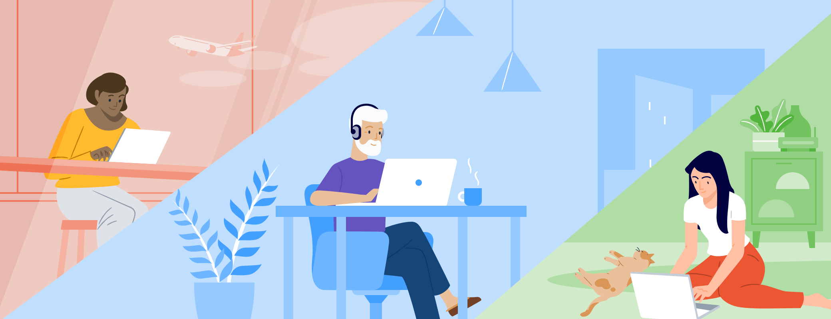
During this challenging time, we have to make some changes to how we do things. One change is that we will be learning and doing activities from home instead of at day program. This is because large groups of people should not be together right now. Learning from home is different, but having expected behavior is the same. It is expected that we are safe, respectful and responsible across environments. Here is how we can be safe, be respectful and be responsible during remote learning.
Be Safe | Be Respectful | Be Responsible
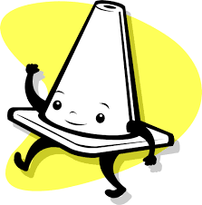 | 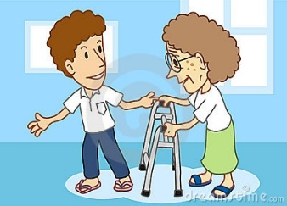 | 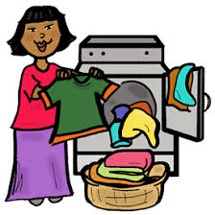
Keep social distancing while learning  Wipe down surfaces before/after use  Push in chair when finished  Cover mouth (tissue/elbow) if couging/sneezing | Arrive on time  Take turns  Use kind language  Keep hands and feet to self | Complete work assigned  Take care of your personal items  Be a good listener  Report problems to staff

4/2020

