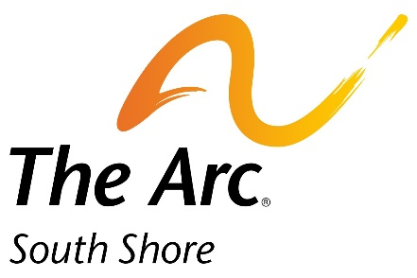

DONATION AGREEMENT FORM
(This form MUST be completed in full and accompany your donation.)

Donor/Company (to be noted on bid sheet)

Contact Name

Address

City State Zip Code

Email

Donor website (if applicable)

ITEM(S) DESCRIPTION:

If you are unable to mail your donation, please contact us and we will be happy to pick it up: EJones@ArcSouthShore.org or at 781-335-3023 x 2209

Fair Market Value of Item(s) $ to The Arc of the South Shore

This donation will be a contribution to our raffle and silent auction for The Arc of the South Shore’s Holiday Festival to be held on Sunday, December 4, 20212. All donations will be prominently displayed at the event with any additional marketing supplies you provide.

Please Note: An acknowledgement form for tax purposes will be mailed to you. The Arc of the South Shore is a 501(c)(3). Our federal tax exemption ID is 04-2302069.

I am authorized to make this donation to The Arc of the South Shore.

Donor’s Signature Position Date

The Arc of the South Shore
Elizabeth Jones, Grant Writer
20 Pond Park, Suite 113
Hingham, MA 02043
Phone: 781-335-3023 Fax: 781-335-3682
EJones@ArcSouthShore.org

